HK INSTITUTE OF VOCATIONAL EDUCATION
DEPARTMENT OF INFORMATION AND COMMUNICATIONS TECHNOLOGY

ITP4910 Software Development Project

LAB 01 – Using Visual Studio 2010 (VS2010) Environment

Objective: To learn how to use the Visual Studio 2010 environment to create a simple project.

Part A: Starting Visual Studio

To start Visual Studio click the Start button at the bottom left of the computer screen, place your mouse over Programs and then select Microsoft Visual Studio 2010 then select Microsoft Visual Studio 2010. Later on, for starting VS2010 we will use the following notation:

Start → All Programs→ Microsoft Visual Studio 2010 → Microsoft Visual Studio 2010.

A VS2010 window will appear as follows.
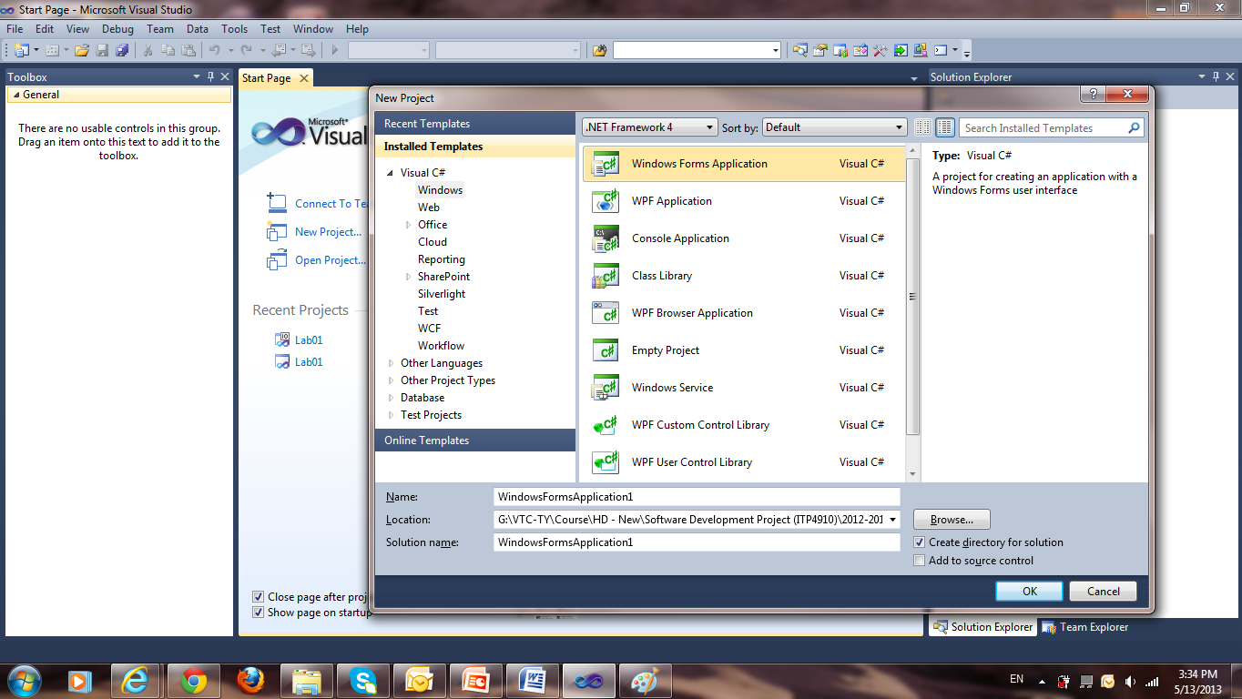

- Click the button New Project and choose Visual C# projects and Windows Applications.

- Next, you must give your project folder a name. VS2010 will automatically put it as WindowsApplicationX (where X is a number). Enter Lab01 in the Name box.

- The following figure identifies the layout of the Visual Studio 2010 window.
They may not appear as same as in your computer, but you can still find the following in your Visual Studio environment:
Form window, Code window, Properties window, Project Explorer window, Toolbar window, Menu bar, Tool bar, Play button.
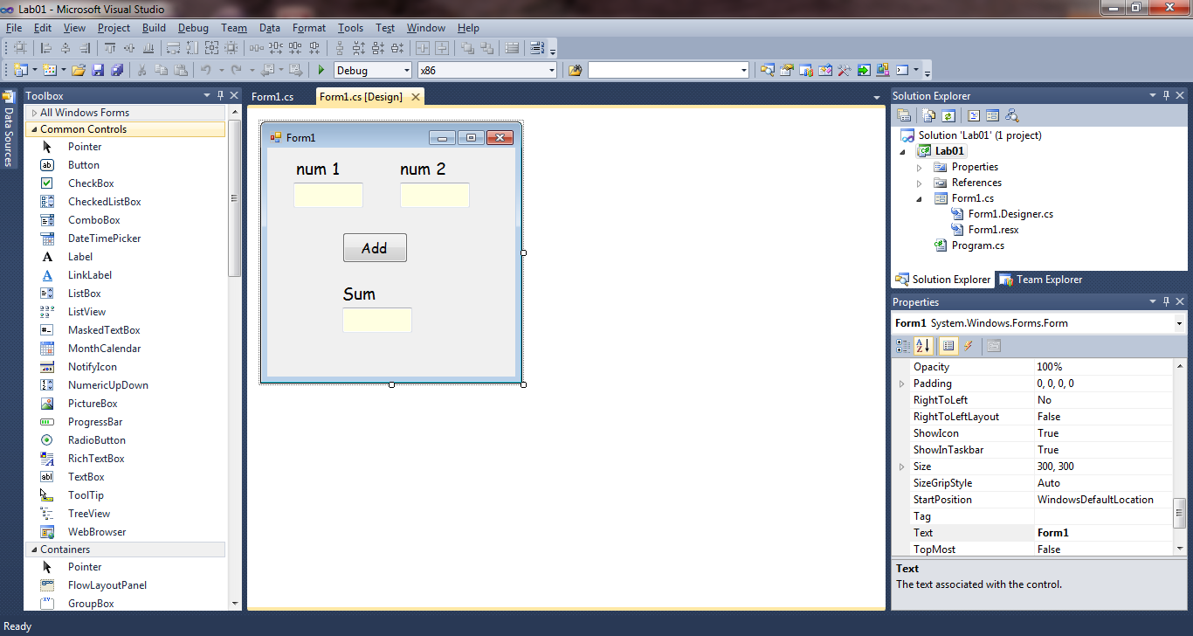
Menu bar
Code Window
Form
Properties
Windows
Toolbox
Play
Button
Tool bar
Textbox control
Solution Explorer

If you cannot locate your windows, you may recall it from View menu in the menu bar.

Part B: Adding Controls from Toolbox to the Form and Changing Their Properties

- From the Toolbox window, double click the Textbox symbol (the one with ab|). The textbox will then appear on the form. (Or you can drag a textbox to the form)
- Click the textbox in the form to select it.
- After textbox has been selected, change its properties in the Properties window.
- Notice that its Name property is set to textbox1.
- Set its location property to 30,40. Note that the textbox moves!
- Set some properties of textbox1 as follows. Pay attention to the textbox in the form while you make changes.

BackColor : Info
ForeColor : Windowtext
Font : Times News Roman 14

- Add 2 more Textboxes. Their names are automatically set to be textbox2 and textbox3. Try aligning the textboxes according to the screen capture below.
- Add 3 Labels controls and their names are automatically set to be label1, label2, and label3.
- Add a Button control (the one which looks like a button). Its default name will be Button1.
- Make sure that the Properties of each control are set according to the following table.

Name | Backcolor | ForeColor | Font | Text | TextAlign
textbox1 | Info | Windowtext | Times 14 | *blank
textbox2 | Info | Windowtext | Times 14 | *blank
textbox3 | Info | Windowtext | Times 14 | *blank
label1 | Control | Windowtext | Comic 14 | num1 | Middle Center
label2 | Control | Windowtext | Comic 14 | num2 | Middle Center
label3 | Control | Windowtext | Comic 14 | sum | Middle Center
button1 | Control | Windowtext | Comic 12 | Add

* By blank, we mean that you do not enter anything in there and leave it empty.

- Align the labels and textboxes properly by grouping and using the alignment toolbar (on the third row from top).

The result is something like this (well, it is not finished yet!):

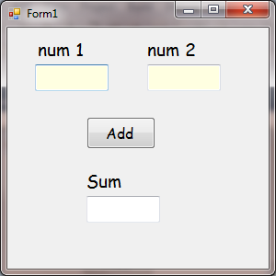

Part C: Writing program (code) in the Code Window

- Double-click the button in the form. Then the Code window will be fully visible. Within the code window, we can see a piece of code that will be executed when the button is pressed:

private void button1_Click(object sender, EventArgs e)
{

}

- At this point, there is nothing inside this Method. The method is call Button1_Click( ) and will be executed when Button1 button is clicked. You can add in your own code (C# is case-sensitive).

private void button1_Click(object sender, EventArgs e)
{
int x = Convert.ToInt32(textBox1.Text) +
Convert.ToInt32(textBox2.Text);
textBox3.Text = Convert.ToString(x);
}

Briefly, the code works as follows:
- textbox1.text – the text property of textbox1 (recall that textbox1 is a Textbox object).
- Convert.ToInt32(textbox1.Text) – textbox1.Text is a character string (a series of characters). In order to convert its type into integer, use the Convert.ToInt32 function (converting a string to an integer).
- x = Convert.ToInt32(textbox1.Text) + Convert.ToInt32(textbox2.Text) – add the 2 values together and assign the resulting value to x.
- textbox3.Text = Convert.ToString(x) – Convert x to a string by the Convert.ToString function and place result to textbox3.Text.

Part D: Running the Program

- In the tool bar, click the Play(debug) button.
- Enter integer numbers into textbox1 and textbox2. Then click the Add button. Your program should output the sum of the 2 numbers.

Part E: Stopping the Program and Making Modifications

- Before you can make modification of the program, you must stop it by clicking the Stop button in the tool bar.
- Change the name of textbox1 to txtNum1 and name of textbox2 to txtNum2 in the Properties window.
- Try running the program again and observe the result. Does it work? If not, modifies the program code to correct the error.

